

Mechanical Group Progress Report

M227562 Alex Rubtsov

Contents

Introduction 3

My Contribution 3

Designing the Lathe Logic Board 4

Disassembling of the lathe 4

Final Lathe Version 3 5

Version History of the Lathe 5

Selection of the Ball Screws 6

Conclusion 7

# Introduction

Our primary goal for the Semester 1 was to automate a ***Colchester Student 1800 Lathe*** that was originally completely mechanical. During the Term 2 of the lathe project we were tasked with the full model of the lathe be completed along with all of the components be ordered and completed hence we weren’t able to fully automate our lathe due to the multiple projects occurring in the FabLab.

# My Contribution

My Contribution to the mechanical team consisted of:

* Designing the Lathe Logic Board
* Putting together the Final Version 3 of the Lathe / Fixing any problems / adding changes
* Disassembling of the Lathe
* Adding Version History of the Lathes in photographic form
* Selection of the Ball Screw

## Designing the Lathe Logic Board

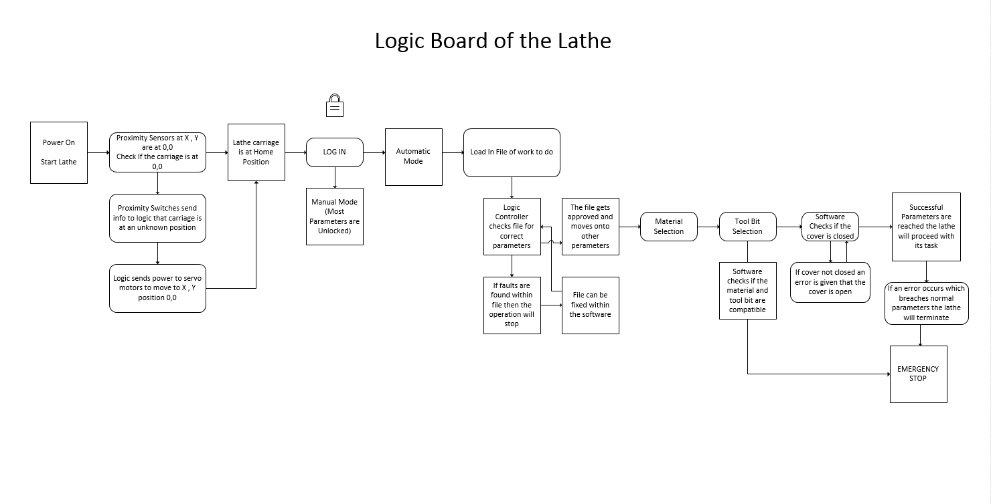This particular task was assigned by John Vivian to complete a rough copy of the lathe “Logic Board”. A logic board is how our lathe will run on the computer that means that there will be certain parameters that the lathe will have to follow. For example the lathe will always try and find its home position if it loses its position.

## Disassembling of the lathe

Nimesh and I were disassembling the gear box of the lathe, Ross told us to take off only certain parts and gears, there weren’t too many things to take off but it did take us almost two sessions to do so. Many of the challenges that we were faced with was the small and tight spaces to take off the C-clips.

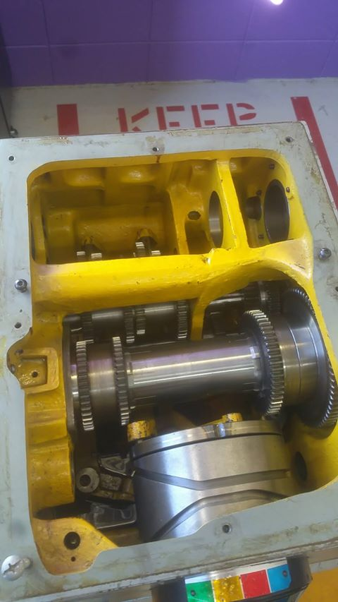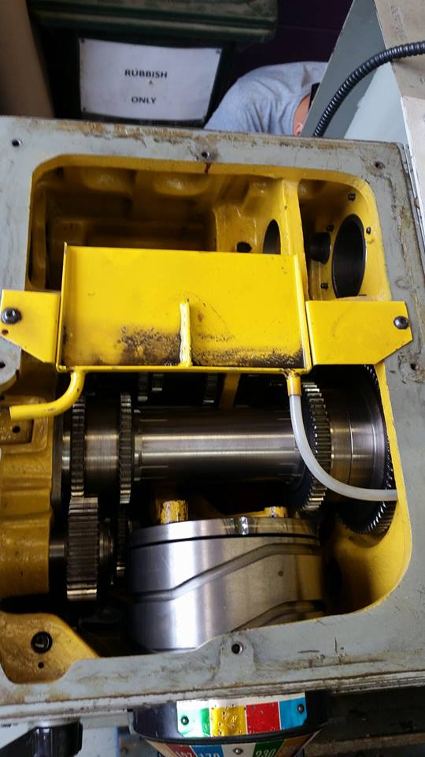 (Before) (After)

## Final Lathe Version 3

Closer to the end of the semester 1 I was tasked with getting all of the updated parts and putting them into our final version of the lathe. This was a fairly easy process as the lathe was already assembled and all I had to do was update some parts and insert some new parts. This is what the lathe looks like in Version 3.

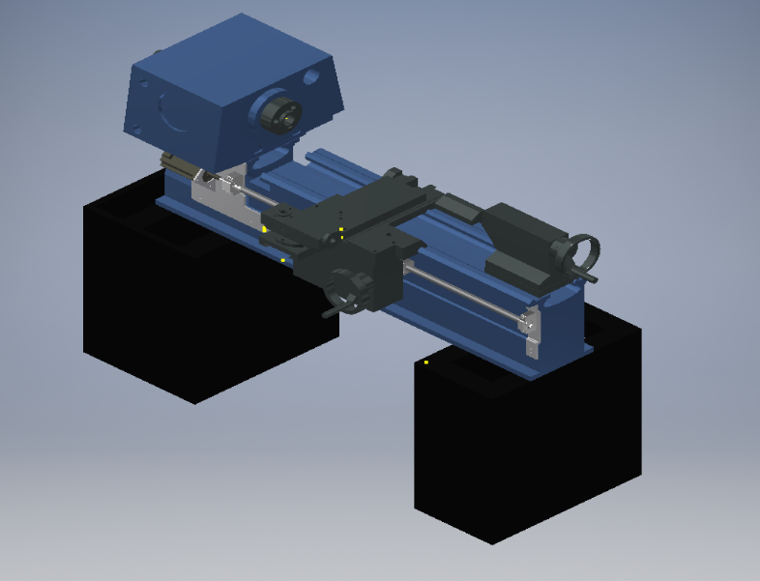

## Version History of the Lathe

This was a pretty simple task, I’ve filtered through our models and took screen shots of the models and divided them into three versions.

Version 1 Version 2

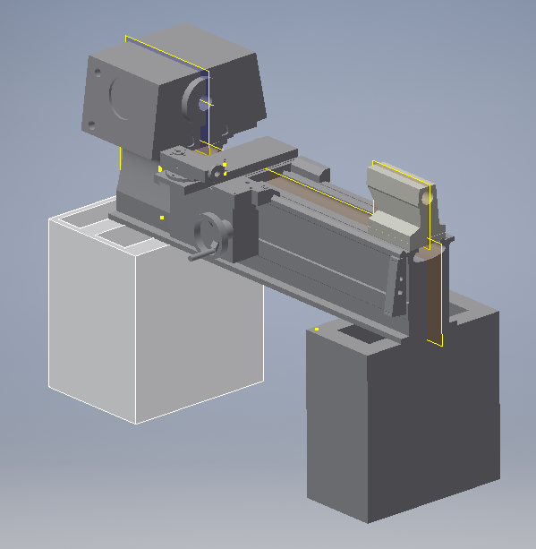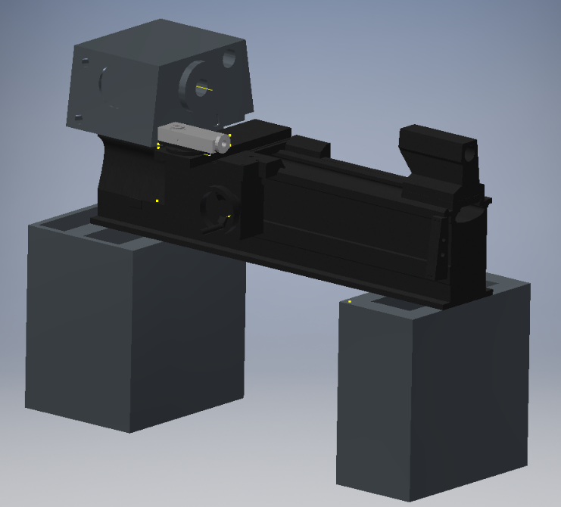

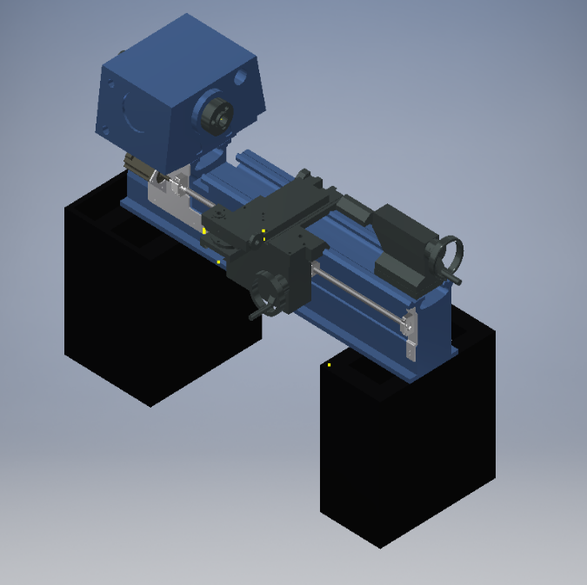 Version 3

## Selection of the Ball Screws

At the start of the project we split into mechanical groups and I was tasked with finding a ball screw that was appropriate for our lathe, I was told to find a ball screw along with the housing the ball screw will sit in. There were two different ball screws one was the long ball screw and one was short. The THK website provided us with 3D CAD drawings of the ball screws and the housings as well. However my selection of the ball screw was passed onto Miguel which did the selection of all the 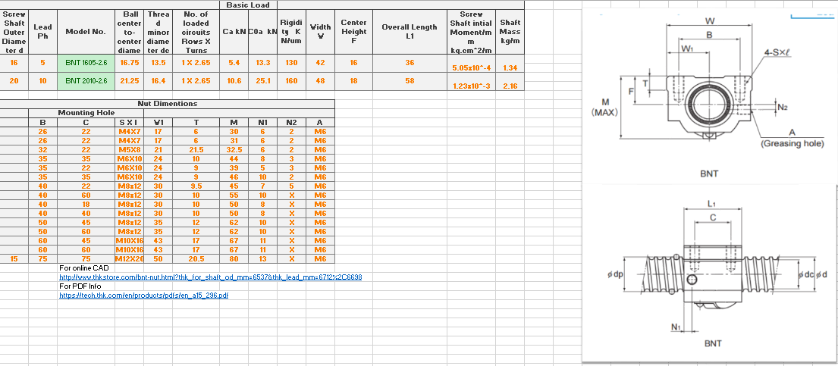ball screws. I’ve also created an excel sheet which showed different info on the ball screws.

# Conclusion

In conclusion I think that this semester ended quite well. We managed to select and order the ball screws along with completing our lathe model. I think that as a group we have achieved enough to be able to completely automate the lathe by the end of semester 2 at the rate we are going.